**Assisted Practice: 3.6 Detach an EBS Volume**

This section will guide you to:

* Detach an EBS volume from an instance

This lab has three subsections, namely:

3.6.1 Selecting the EBS volume you want to detach

3.6.2 Detaching the volume

3.6.3 Pushing the files to GitHub repositories

**Step 3.6.1:** Selecting the EBS volume you want to detach

* Choose the bucket

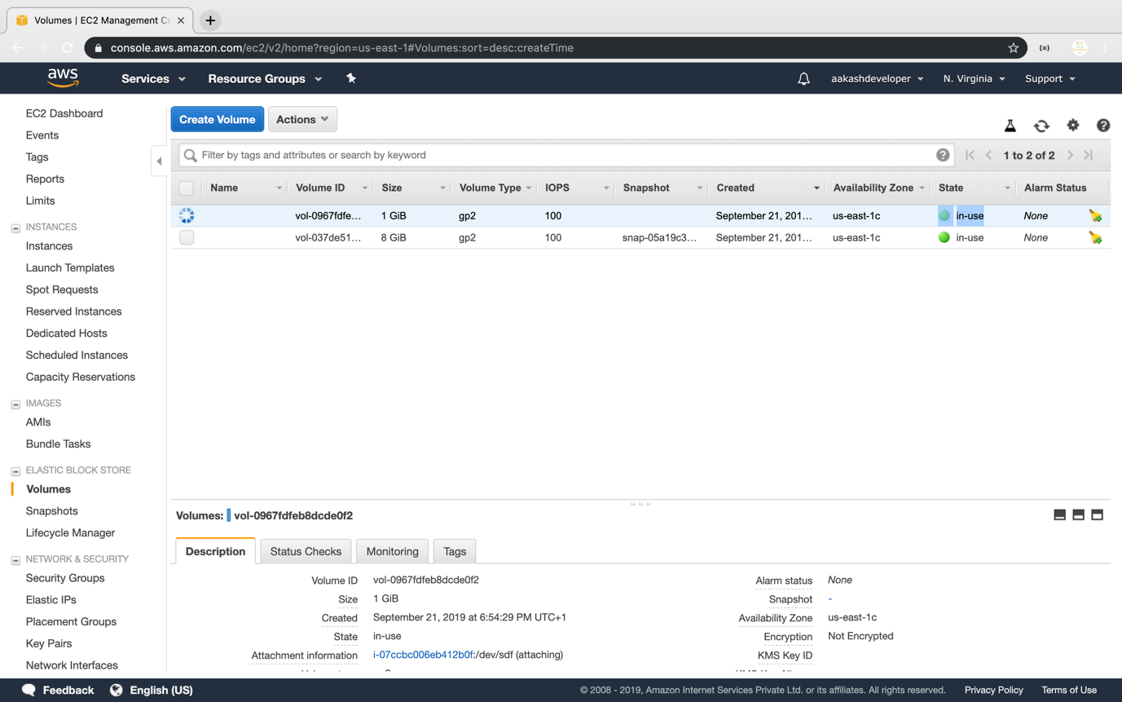

* Select *Detach Volume* option

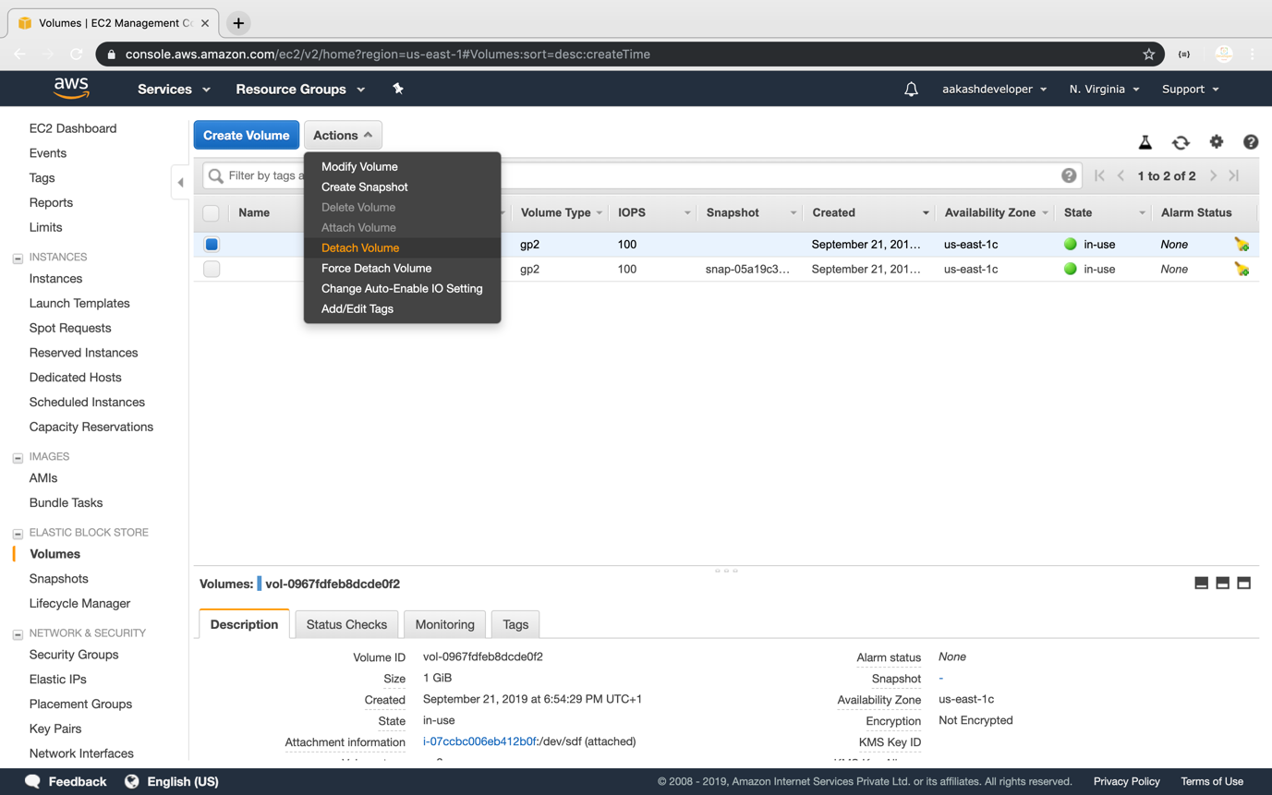

**Step 3.6.2:** Detaching the volume

* Select *Yes* once the confirmation pop-up appears

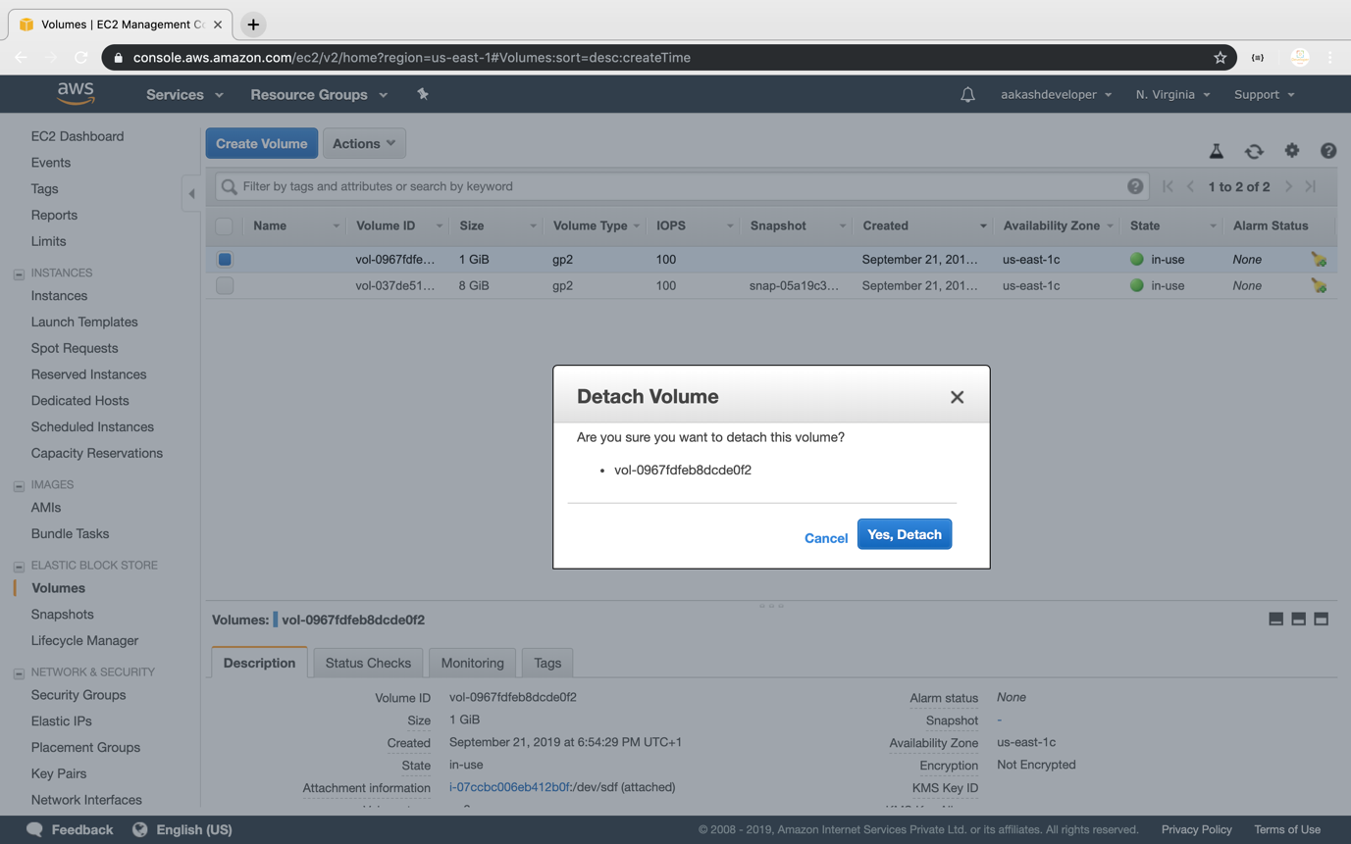

* Once detached, the volume will be labeled as *Available*

